**Exp 03: Create a simple cloud software application for Property Buying & Rental**

**process (In Chennai city) using any Cloud Service Provider to demonstrate**

**SaaS.**

**Aim**

To design and deploy a simple cloud-based software application for the **Property Buying & Rental process in Chennai city** using **Zoho Creator**, demonstrating the **Software as a Service (SaaS) model** with basic input forms.

**Procedure**

1. Login to Zoho Creator – Open Zoho Creator and start a new application.
2. Create Form 1: Property Listing – Add fields like *Property ID, Location, Type (Buy/Rent), Price*.
3. Create Form 2: Buyer Details – Add fields like *Buyer ID, Name, Contact, Preferred Location, Budget*.
4. Create Form 3: Rental Details – Add fields like *Tenant Name, Contact, Duration (Months), Rent Budget*.
5. Create Form 4: Transaction Form – Add fields like *Property ID, Buyer/Tenant ID, Final Price/Rent, Date*.
6. Deploy the Application – Save, test, and deploy the app as a SaaS-based solution accessible via the cloud.

**Output**

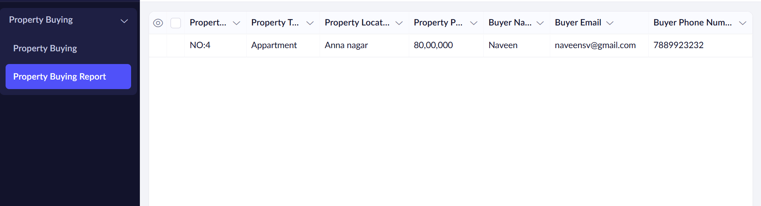

**Result**

Thus, a simple cloud-based application was successfully created and deployed using **Zoho Creator**, and it was provided as a **Software as a Service (SaaS)** model for end-users to access online.